دورة القدرات "تأسيس كمي" من منصة همة القدرات

الفهرس:

1.الأعداد العشرية

2.الكسور

3.الجذور

4.الأسس

5.النسبة المئوية

6.التناسب الطردي والعكسي

7.المثلث

8.الدائرة

9.المربع

10.المستطيل

شرح درس الأعداد العشرية من التجميعات

(الأعداد العشرية)

(ضرب الأعداد العشرية)

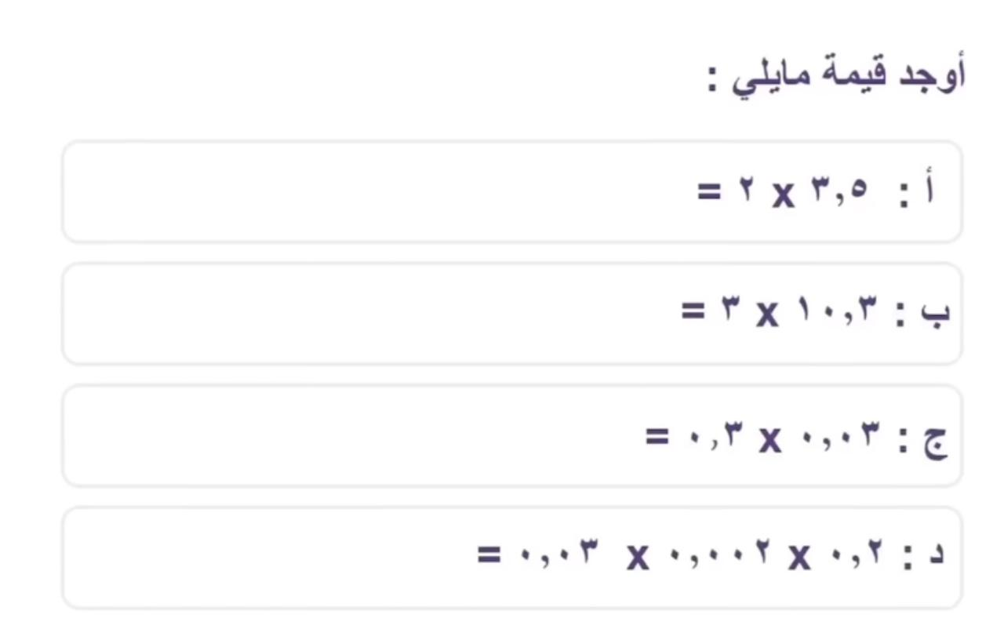

(قسمة الأعداد العشرية)

(جمع وطرح الاعداد العشرية)

(الكسور)

(الجذور)

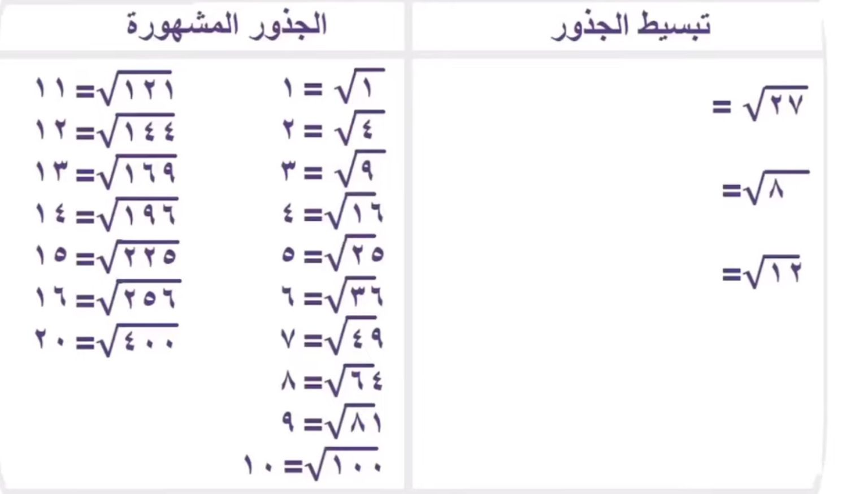

(الأسس)

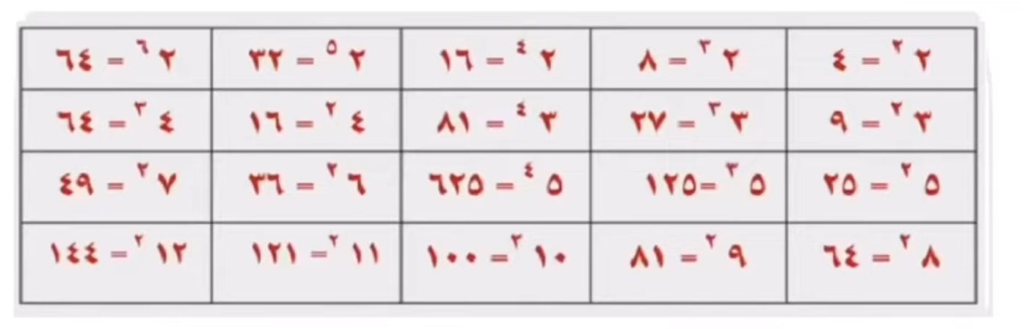

(النسبة المئوية)

(التناسب الطردي)

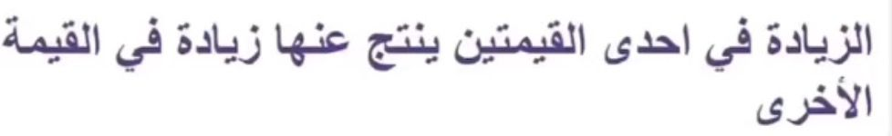

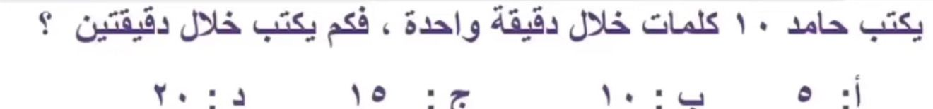

(التناسب العكسي)

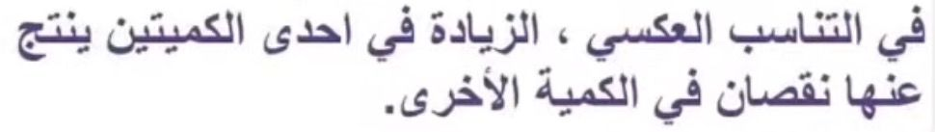

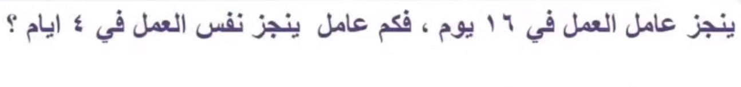

(المثلث)

(الدائرة)

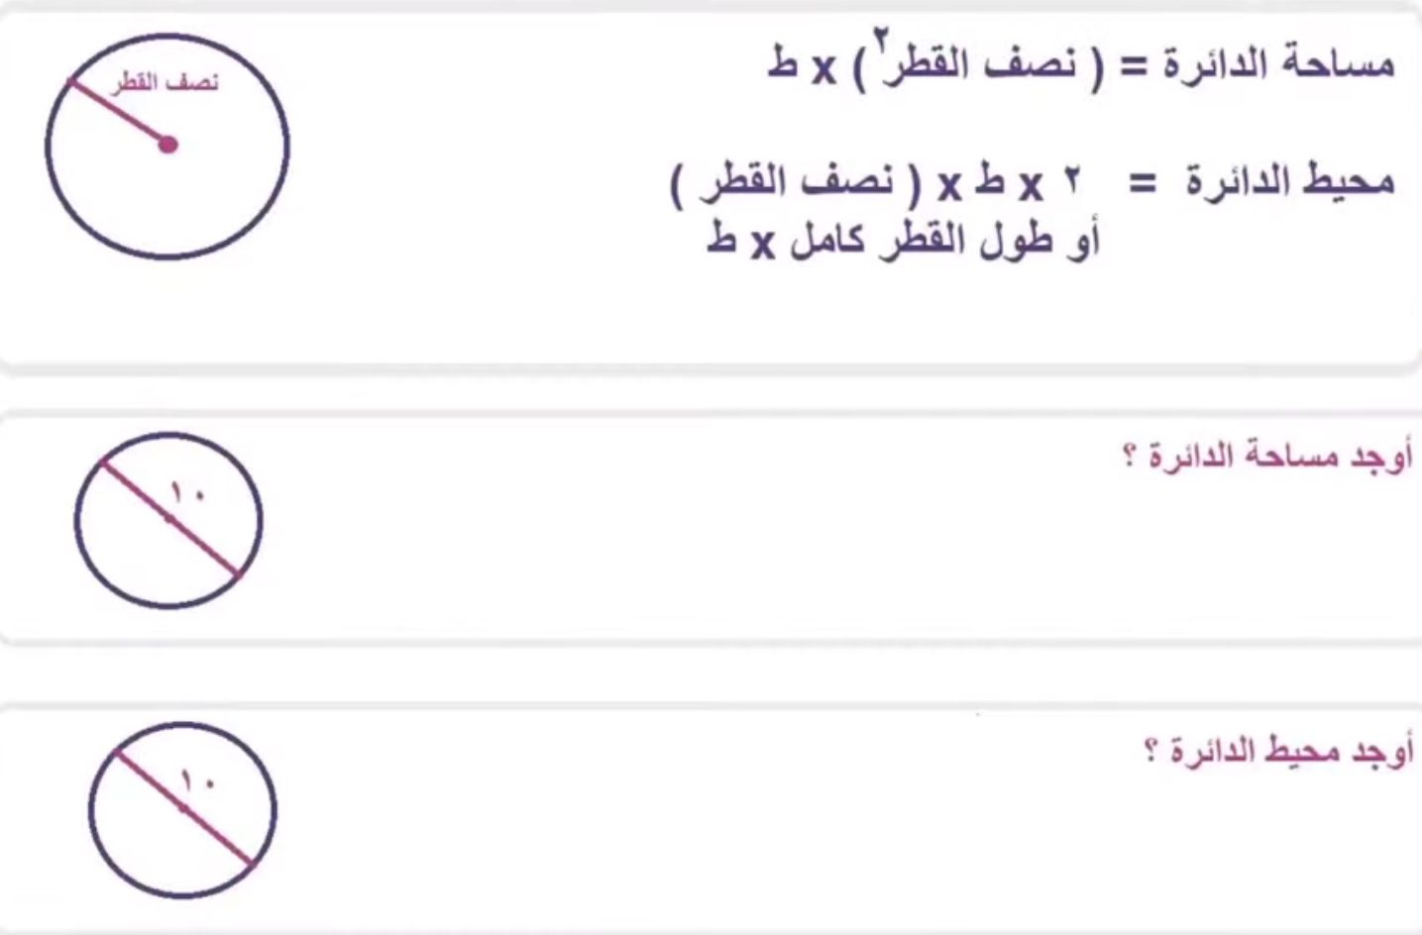

(المثلث داخل الدائرة)

(المربع داخل الدائرة)

(المربع)

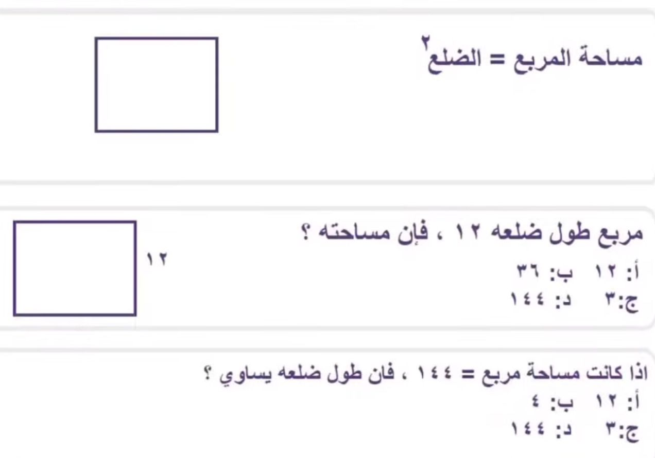

(المستطيل)

